Risk of Bias
Introduction
The extent to which a systematic review/meta-analysis (SR/MA) can draw conclusions about the effects of an intervention depends on whether the data and results from the included studies are valid. In particular, an SR/MA of invalid studies may produce a misleading result, yielding a narrow confidence interval around the wrong intervention effect estimate. The evaluation of the validity of the included studies is therefore an essential component of SR/MAs, and should influence the analysis, interpretation, and conclusions of the SR/MA. Standardized “risk of bias” (RoB) tools are used to measure the extent of various types of biases from individual studies.
The validity of a study may be considered to have two dimensions. The first dimension is whether the study is asking an appropriate research question. This is often described as ‘external validity’, and its assessment depends on the purpose for which the study is to be used. External validity is closely connected with the generalizability or applicability of a study’s findings. The second dimension of a study’s validity relates to whether it answers its research question ‘correctly’, that is, in a manner free from bias. This is often described as ‘internal validity’. A good meta-analysis should assess both external validity and internal validity and should incorporate measures to minimize the risk of such biases.
Below are SME’s procedures for performing RoB assessments for systematic reviews and meta-analyses.

Process
Once all study screening tasks have been completed, you are ready to start the RoB analysis for each of the included studies. The goal of the RoB assessment is to assess the risk of bias in study design and execution, in addition to evaluating the validity of the estimated treatment effect of the intervention or exposure for each included study.
All SME documents relevant to the RoB analysis are stored in the SME Manuscripts Team Drive. Project materials are stored in the Risk of Bias folder. The Instructions subfolder includes instructions for completing each type of RoB assessment, and the Templates subfolder includes Excel templates for completing each type of RoB. The overall process for performing RoB analysis is shown in Figure 1 and is described below:
- Assign the quality control reviewer and independent RoB reviewers.
  - It is the responsibility of the study coordinator to assign the quality control (QC) reviewer and independent RoB reviewers at the beginning of the project start. Typical RoBs require 1 QC reviewer and 2 independent RoB reviewers.
- Determine the correct RoB to use:
  - Different study designs (Case Control, Cohort, etc.) will use different versions of an RoB. Most RoBs will consist entirely of randomized controlled trials and/or cohort studies; however, different study designs may be included depending on the project. If necessary, discuss with the study coordinator (most likely John Pederson, jpederson@supedit.com) to determine which RoB should be used. Note that it is the responsibility of the QC reviewer to determine the correct RoB form.
  - Familiarize yourself with the different sections of the RoB you are using. Information on the different RoBs can be found in the Risk of Bias folder of the SME Manuscripts Team Drive. The common RoBs are,
    - Scottish Intercollegiate Guidelines Network (SIGN)
        - Systematic Reviews and Meta-analyses
        - Randomized Controlled Trial
        - Cohort
        - Case Control
        - Diagnostic Accuracy
        - Economic Evaluations
NOTE: The instructions for the SIGN RoB are quite long (100+ pages!). The good news is that most of the information is not particularly relevant for the majority of SR/MAs. For quick reference, the most important sections to review are page #51 and pages #56-66. Other sections may be useful depending on the project.
    - modified Newcastle-Ottawa Scale (mNOS)
      - Cohort
      - Case Control
    - Joanna Briggs Institute (JBI)
      - Case Report
      - Case Series
    - Cochrane
      - Randomized Trial
      - Non-Randomized Study
  - Know which study designs you are including in the SR/MA. SME has a training video on various study designs. Be familiar with these study designs and choose the correct RoB template based on the studies included in the SR/MA.
  - Normally, two RoB reviewers will complete an RoB individually. Do not collaborate on one with your fellow reviewer because your RoB assessment would be biased.
  - An experienced QC reviewer should adjudicate results of the RoB and resolve any conflicts between RoB results from the independent reviewers.

- Use the correct template:
  - Use the correct template for each study. Different study designs warrant the use of different templates. It is the responsibility of the QC reviewer to determine which template to use.
    - Note: QC reviewer’s determination of study design (and thus, RoB template selection) should be based on the utility of the study design for the purpose of the SR/MA, not necessarily the individual study’s design as described in the article.
      - Example 1: A study may incorrectly describe itself as a cohort study when it would be more appropriate to label it as a case series. For the purpose of the meta-analysis, consider this study a case series.
      - Example 2: You are performing an SR/MA investigating differences in medication dosing regimens for spine surgery. An included study correctly describes itself as a randomized controlled trial, but it randomizes patients to receive one of two relevant spine surgeries; patients in both groups receive the same medication dosing regimen. For the purpose of the meta-analysis, this study should be labeled as a prospective, single-arm cohort.
    - Note: All RoB templates exist as both Excel files and Google Sheets in the Risk of Bias folder of the SME Manuscripts Team Drive. The Google Sheets RoB templates are incorporated in the SME Google Sheets Template Gallery, which may be used to quickly and easily create new RoB’s in project folders by clicking “New > Google Sheets > From a template.” If any updates to an RoB template are needed, please perform the update in the corresponding Google Sheet RoB template as well, since only

    - SIGN Template: Use the SIGN template by default (see below sections for exceptions). SIGN includes templates for various study designs, including:
        - Systematic Reviews and Meta-analyses
        - Randomized Controlled Trial
        - Cohort
        - Case Control
        - Diagnostic Accuracy
        - Economic Evaluations
    - mNOS Template: This template includes a page for Cohort and for Case Control studies. Use mNOS template by default when the SR/MA is ONLY comprised of case control and/or cohort studies OR if requested by a client OR if requested by a journal/reviewer.
    - JBI Template: This template includes a page for Case Reports, Case Series, Cohort Studies, Randomized Controlled Trials, and Quasi-experimental studies. Use the JBI template by default when the SR/MA involves any case reports and/or case series OR if requested by a client OR if requested by a journal/reviewer.
    - Cochrane Templates: The Cochrane Templates have the most difficult instructions and will most likely not be used. The Cochrane Templates are applicable for both randomized studies (see RoB 2) and non-randomized studies (see ROBINS-I). Use the Cochrane template by default ONLY if requested by a client OR if requested by a journal/reviewer.
- Follow-through
  - For independent RoB reviewers: Perform the RoB assessment. When finished, email the QC Reviewer and study coordinator when your RoB is complete. The RoBs from the data collectors can then be compared and combined. Next, start on data collection of each included study.
    - Note: If independent reviewers create their RoB’s using the New > Google Sheets > From a template route, this helps ensure that independent reviewers have uniform formatting in their RoB forms, which eases the process of adjudication for the QC reviewer later.
    - Note: RoB questions should be answered according to the context of the SR/MA, not necessarily according to the study’s design when assessed independently.
      - Example: You are working on an SR/MA primarily investigating hip dislocation following total hip replacement. A case series included in the SR/MA measures their primary outcome (osseointegration) in a valid/reliable way but does not specify any measurement for their secondary outcomes (dislocation). For an RoB question asking about measuring the outcome in a valid/reliable way, this study would not receive credit.
  - For QC reviewer:
    - First, adjudicate the RoB responses. Response comparison can be performed manually for small projects, but for larger projects, it is recommended to use the methods described here (see RoB Match Determination in Excel).
    - Then, write up the RoB results in the manuscript. See SME’s RoB Write-Up document for examples and a guide of how to present RoB information in the manuscript. Email the study coordinator when this process is complete.

Figure 1. Flow chart of the risk bias analysis process.
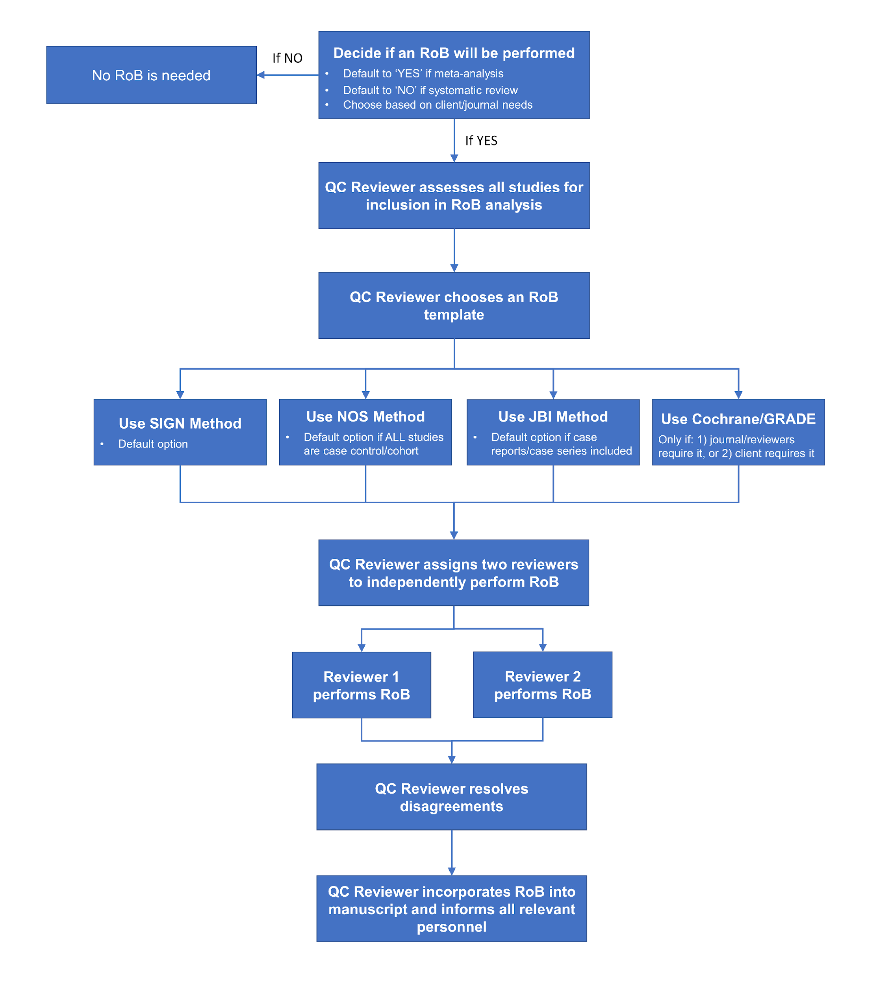

REVISION HISTORY
Date | Individual Making Change | Synopsis of Change
6/4/2021 | John Pederson | Created document Risk of Bias SOP.
6/7/21 | Jillienne Touchette | Updated document location link
7/19/21 | John Pederson | Described which SIGN RoB sections are most important to review.
9/10/21 | John Pederson | Changed description of when JBI method should be used. Also made it clear that the QC reviewer is responsible for any method of RoB data presentation in the manuscript.
9/17/21 | Alex Mebane | Inserted link to RoB Match Determination in Excel document with a brief overview of steps
9/27/21 | Alex Mebane | Added information about Excel vs. Google Sheets versions of RoB templates in the Risk of Bias folder; the Google Sheets Templates Gallery; and the New > Google Sheets > From a template route of creating RoB’s from existing templates
10/7/21 | Alex Mebane | Added a link to the RoB Write-Up: Examples and Guide document for the QC reviewer
11/9/21 | Alex Mebane | Added clarification that the QC reviewer’s determination of study design (and thus, RoB template selection) should be based on the utility of the study design for the purpose of the SR/MA
11/23/21 | Alex Mebane | Added clarification that RoB questions should be answered according to the context of the SR/MA

